**Easter Manual Workshops for students**

**Easter in Poland is a very important time, that’s why we can prepare some decorations referring to this holiday. I hope you will have a lot of fun and you will transfer yourselves in the magic Esater time.**

**Workshop no. 1 Esater-Ersamus+ Palm**

Students are going to prepare Easter Erasmus+ Palms. The palms are going to be in national colours of each partner counry.

Necessary things: colourful paper, glue, scissors, long wooden toothpicks, polyystyrene eggs.

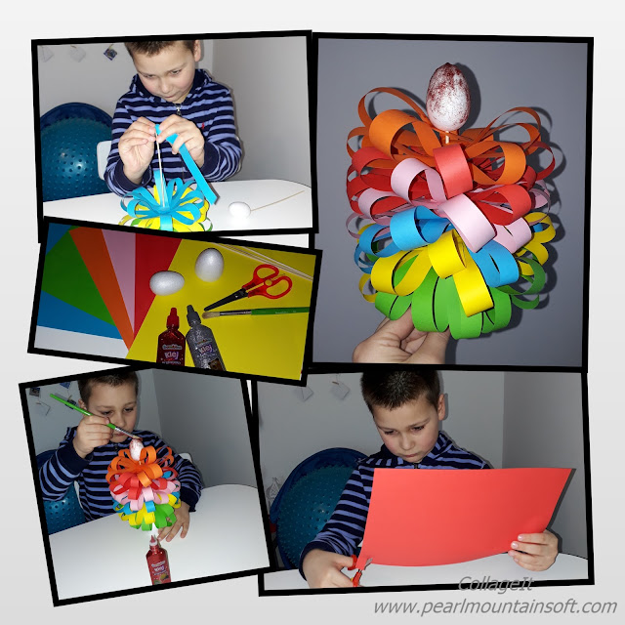

**Workshop no. 2. Easter Erasmus+ Eggs**

Students are going to prepare Easter Erasmus+ Eggs. They are going to make the eggs colourful. The decorations can refer to the topic of the project-GAMES, to the geography of partners’ countries, etc. You can just use your IMAGINATION!

Necessary things to do it: hard boied egges/polystyrene eggs, blotting paper, paints, brushes, glue, sugar, long toothsticks etc.

Here are some links to watch and see how to make Easter eggs.

[**https://www.youtube.com/watch?v=lEOgtrS3Uk8**](https://www.youtube.com/watch?v=lEOgtrS3Uk8)

**https://www.youtube.com/watch?v=iqKeeyEi2lQ**

**Workshop no. 3 Easter Hare.**

**Students are going to preapre an Easter hare-an Easter table decoration!**

**Necessary things:**

1. The shape of the hare to cut (look below)
2. Felt or foam
3. Colourful ribbons, plastic flowers
4. Chocolate/ plastic or napkins
5. Glue, scissors, needle and sewing thread

Follow the pictures to do it! Look below

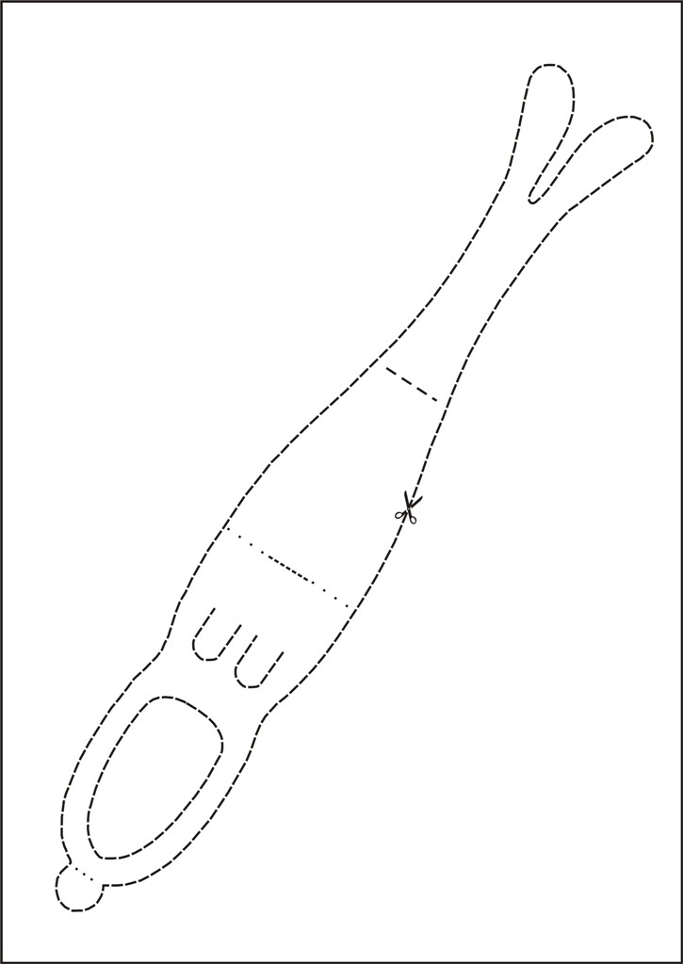

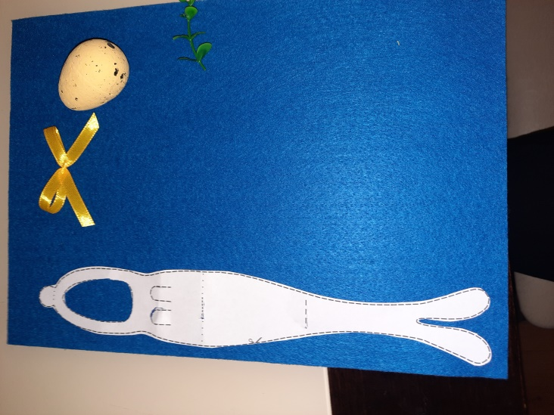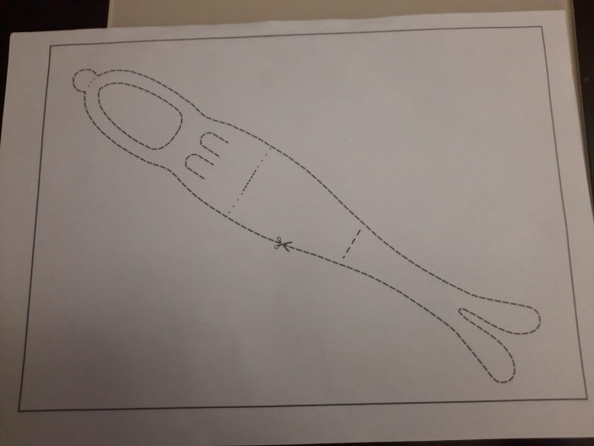

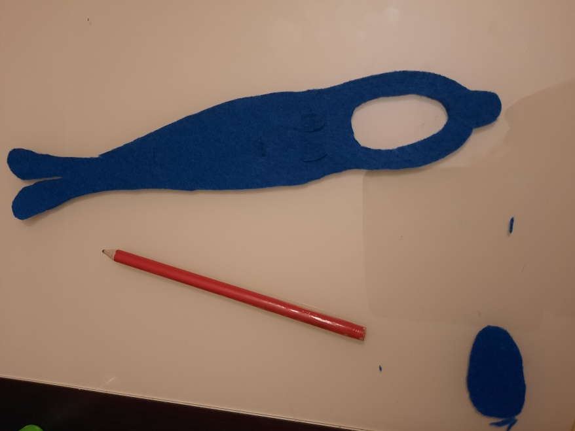

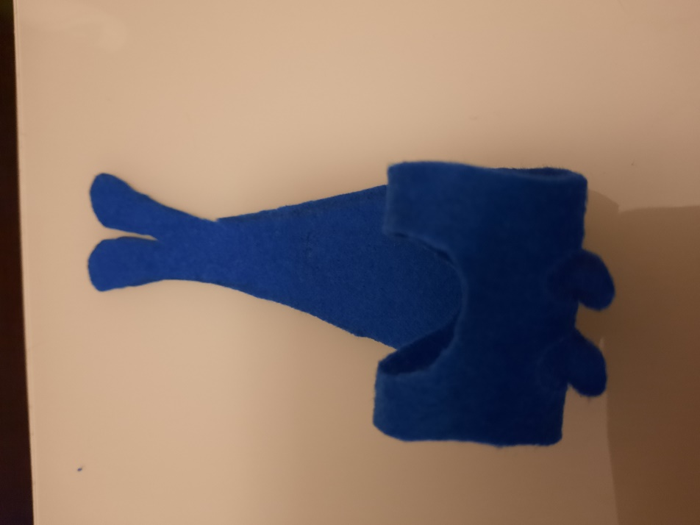

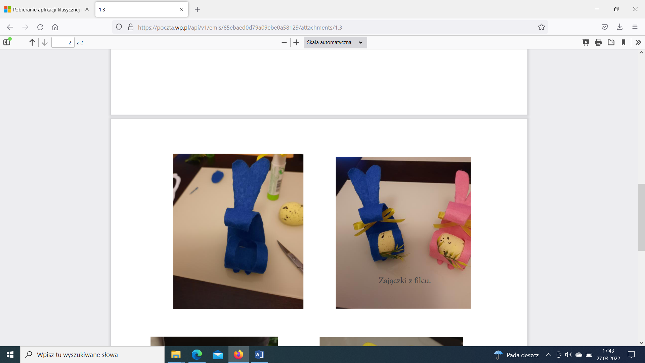

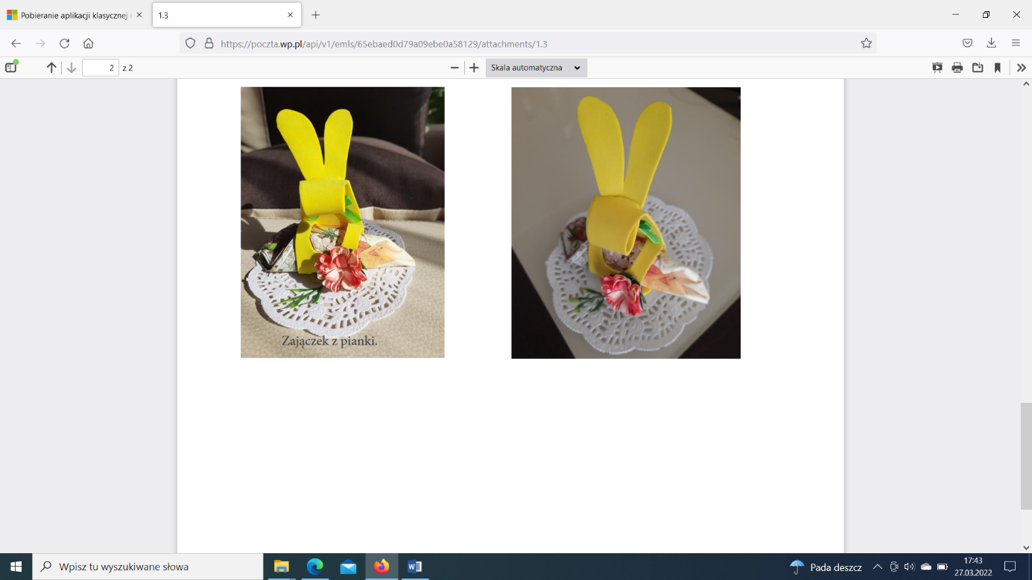

**After preparing all Easter Ersamus+ decorations, students can organise a display for other students at school to show their final products.**

**Workshop no. 4**

**Discussing panel. Topic: LET’s talk about Easter in our cuontries.**

**Students are going to talk about Easter.**

1. **How do we prepare for Easter?**
2. **How do we spend time at Easter?**
3. **What do we eat at Esater? Etc.**